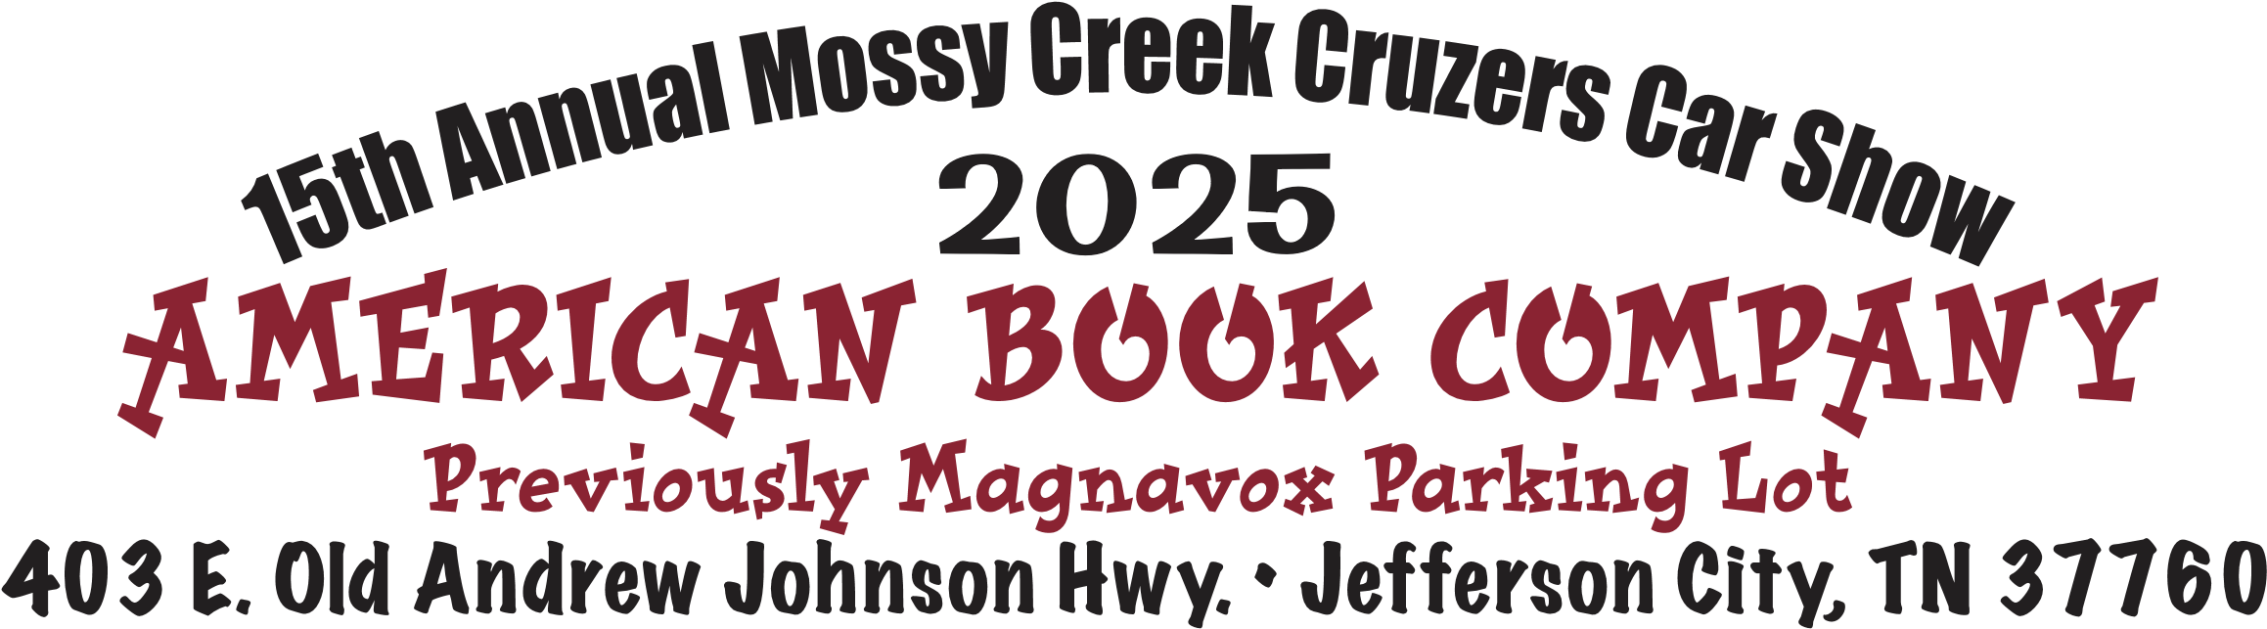

The Mossy Creek Cruzers 15th Annual car show was held on 7/12/2025 at the American Book Company facility in Jefferson City, TN. The event is well organized with plenty of room for cars, spectators, food trucks, and other vendors. The day was clear and hot (always hot due to asphalt and little shade). There is room for chairs and sunshades to be set up (recommended).

There were 139 cars at the show. Most of the cars were American classics from the 40’s – 90’s. There was one (1) British car (1977 MGB) at the event. There were six (6) food vendors and several other merchandise vendors.

There was a silent auction, 50/50 drawing, and envelope prize drawing, cash award giveaways, and door prizes. The announcer kept the event moving and played good music. As a surprise there was also an Elvis impersonator who sang a few songs.

The event was cut a little short due to potential weather moving into the area in the afternoon. The day concluded with the presentation of awards by era. This is a judged event and not popular vote. The awards included a “Best in Show”, “Best in Class”, and Top cars from each era. The one (1) British car attending took home an award for one of the top cars in the 1970’s era class.

This same organization holds a fall benefit show in the Fall located at the Bush Company historical Visitors Center in Chestnut Hill, TN (see upcoming events calendar).

