Members of the East Tennessee British Car Club got together on Saturday, May the 24th 2025, for a beautiful drive in the vicinity of Cherokee Lake.

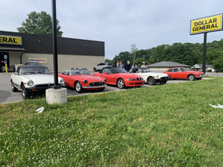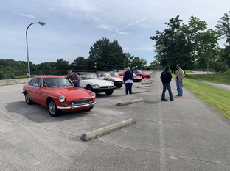

Beginning at the northern end of Lakeshore Drive, we drove south, stopping at the Cherokee Dam, then 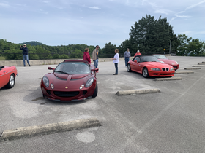continuing on to Jefferson City.

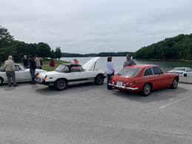

After reaching Jefferson City, we stopped to dine on fabulous pizza at Patriot Wood Fired Pizza. Located in what once was the old 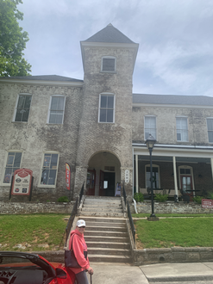City Hall, one of the owners of the building was kind enough to give a tour and shared with us some of the rich history of the building. Enjoyable outing, good food, top down weather and good people!

